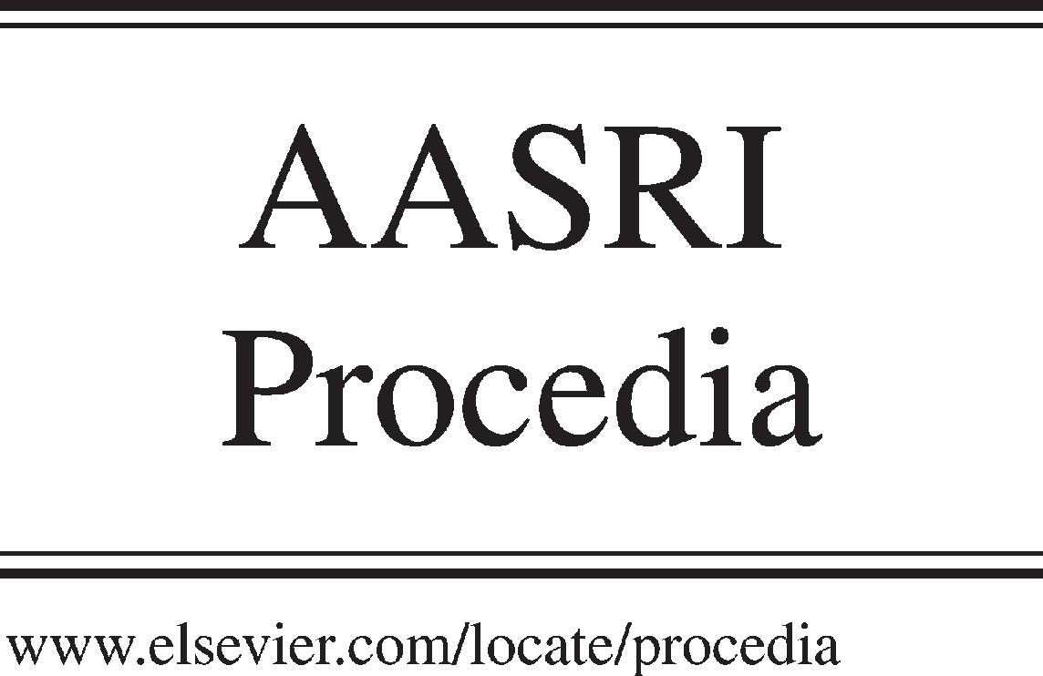Available online at [www.sciencedirect.com](http://www.sciencedirect.com/)



AASRI Procedia 3 (2012) 715 – 720

2012 AASRI Conference on Modelling, Identification and Control

Suspension Parameters Optimize Based on Competition- Cooperation Game Model

Chong Zhi Song a,b , Youqun Zhaoa, Lu Wangb

*a.College of Energy and Power Engineering, Nanjing University of Aeronautics and Astronautics Nanjing, Jiangsu, China, 210016*

*b School of Mechanical Engineering,Anhui University of Technology,Maanshan, 243002, Anhui, China.*

Abstract

Game theory is used to solve engineering problems, according to behavioral expressions, derived a number of algorithms from simulation of human behavior. The paper, adopts competition-cooperation game method to optimize passive suspension. The calculation results show that the competition-cooperation game method could be used to solve muti- objective optimization problems. During the game, all game partiers abide by some constraint protocol based on collective rationality; by negotiating, game partiers make some “concession” mutually, and reach trade-off equilibrium solution. Maybe the results is not the best optimal results to the game party, it is a relatively acceptable solution, which means the co-operative game result for multi-objective is a non-inferior solution.

© 2012 The Authors. Published by Elsevier B.V. Open access under [CC BY-NC-ND license.](http://creativecommons.org/licenses/by-nc-nd/3.0/)

© 2012 Published by Elsevier B.V. Selection and/or peer rev[iew under respon](http://creativecommons.org/licenses/by-nc-nd/3.0/)sibility of American Applied Science Research Institute

Selection and/or peer review under responsibility of American Applied Science Research Institute

Keywords: Passive Suspension, Competition-Cooperation Game Model, Game Theory;

1. Introduction

Also multi-objective optimization has been put up for many years, the application of multi-objective optimization to solve engineering problems never decay. The most important thing in solving multi-objective optimization engineering problems is find the Pareto-optimal solutions. On many occasions, there are no Pareto- optimal solutions [1-3]. So it is imminent to find a good way to solve multi-objective optimization problems. In recent decades, there appeared many algorithms, such as ant colony, genetic, particle swarm, artificial fish- swarm, and the corresponding improved algorithms etc.

Different from the other algorithms, game theory, takes game party elements as human beings, by simulation of human behavior, and gives game partiers selfish, competition, and cooperation adjustability, according to systems. So it evaluated many game theory models to explain social problems, and some scholars use game theory to solve engineering problems. The paper adopts game theory to solve multi-objective

2212-6716 © 2012 The Authors. Published by Elsevier B.V. Open access under [CC BY-NC-ND license.](http://creativecommons.org/licenses/by-nc-nd/3.0/) Selection and/or peer review under responsibility of American Applied Science Research Institute doi:10.1016/j.aasri.2012.11.113

optimization in the field of engineering problems. It gives appropriate optimization algorithm to solve engineering problem, and obtain the best fit suspension parameters.

1. Multi-objective methods based on game theory

The goal of multi-objective optimization is to find the optimize value. While the game theory, is to find each game party's own maximum profit. They have the same similarity: finding the Pareto solution. Game theory is used to solve multi-objective optimization problems, especially in engineering fields. Based on the game party's behavior, game theory can be divided into cooperative, selfish and non-cooperative game.

Cooperative game is all the game partiers follow the same conventions, each game party cooperative with the others for pursuing own maximum profit, maybe the profit is not Pareto solution; Relative to the entire game, the Pareto solution is in its own interests. Compared with cooperative game, non-cooperative game means that all game partiers competitive with each other for the pursuing own maximum profit; During the game, each game party wants its own maximum profit, the result got comes the other game party's lost. The author [4-5] set up a multi-objective solution based on game theory, as well as gave the description of how to transform multi-objective problem to game theory and the calculation of each game party's strategy space. With the adoption of Nash equilibrium model, Stackelberg model, the design results show the multi-objective game method is an effective method. Combined the cooperative and competitive game theory, the paper used competition-cooperation model to optimize a suspension vehicle model, and find a new way to solve multi- object engineering problem.

* 1. *Basic principle*

According to game theory, multi-objective problem can be expressed by mathematics

sets: *G*  *S*1, ⋯, *Sm* ; *F*1, ⋯, *Fm*  , *F*1,⋯, *Fm* are *m* game partiers, *S*1  *xi* ⋯ *x j* ,

*Sm*  *xk* ⋯ *xl*  are the game partiers' strategic space.

* 1. *Game party's strategic space computation*

How to turn multi-objective problems into competition-cooperation problems is the paper's core technology. The most important is turn variable sets *X* into each game party's strategic.

Once design variable's impact factor calculated, it can get each game party's strategic space.

Calculation steps:

* + 1. The first step is: by optimizing single-objectives, it can get the optimal

solution *F* ( *X* *), *F* ( *X* *),⋯, *F* ( *X* * ) , where *X* *  *x*\* , *x*\* , ⋯, *x*\*  (*i*  1,2,⋯, *m*) .

1

1

2

2

*m*

*m*

*i*

1*i*

2*i*

*ni*

* + 1. To any *x j* , *T* division fragments gotten according to step size *x j* ;
    2. Let sample data set be *d*  *d*1 , *d*2 ,⋯, *dn* , and the set of *j* is *dj*   *j*1,⋯,  *jm*( *j*  1,⋯, *n*) .

The author use similarity nearness degree to explain the samples' taxonomic relation. Optional two game

partiers:

*dk* and *dl* , analyzing their similarity nearness degree:

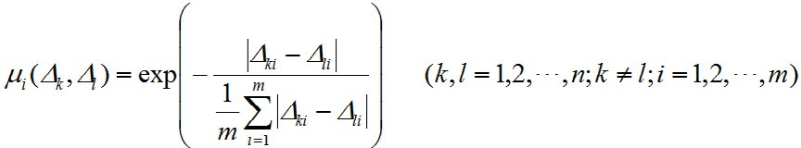Where, *i* (*k* , *l* ) is the fuzzy relation of

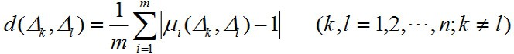*dk* , *dl* ’s Hamming distance is:

*dk* and *dl*

on the *ith*

value.

(1)

*dk* , *dl* ’s fuzzy nearness degree is:

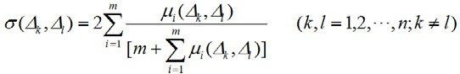

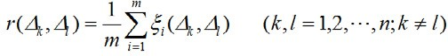*dk* , *dl* ’s correlation degree is:

(2)

(3)

*i* (*k* , *l* ) is the correlation coefficient of *dk* and *dl* on *ith* , and expressed as:

(4)

Considered the above factors, it can establish the similar approach degree of *dk* and *dl* .

Where, *d* is the weight of hamming distance; ** is the weight of fuzzy closeness, *r*

correlation degree, and satisfy the formula *d*  **  *r*  1.

* 1. *Multi-objective solving methods based on competitive and cooperative game model*

(5)

(6)

is the weight of

The paper’s main core ideology is that: the constraint rule is “egoism but harmless to others”, which means when pursuing optimal profit, each game party must harmless to the others. To any game party, the absolute profit *ui* is self-profit during action strategy, while the relative strategy *u*ˆ*ij* ( *j*  1,⋯, *i*  1, *i*  1,⋯, *m*) is the profit to the others during action strategy.

Definition the competitive-cooperative game strategy: *s*1, *s*2 ,⋯, *sm*  , merged by each game party’s

strategy, if game party’s strategy *s*\* satisfied the following formula:

*i*

1)



2)

*s*\* is the game party’s “ competitive  cooperative Game Strategy ”; all

*i*

* combined into one strategy

*s*

*i*

*s*\* , *s*\* ,⋯, *s*\* ☒, it is the “ Competitive  cooperative Equilibrium ”.

1

2

*m*

1. Calculations and analysis

The paper's parameters and the Multi-objective optimization design model shown in paper [4-5]. Compared with the original parameters, almost all the parameters have been optimized. The whole vehicle performance and the ride comfort are all improved.

Table.1 The comparison of game design and initial design

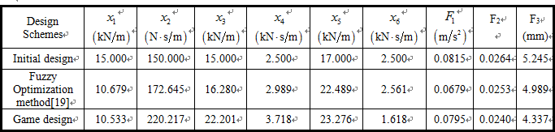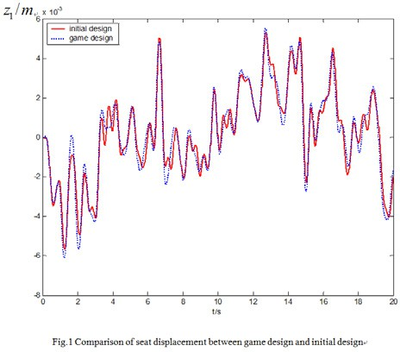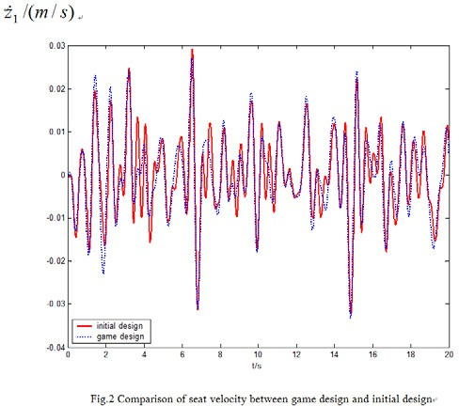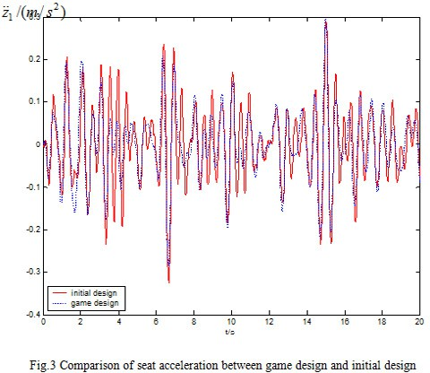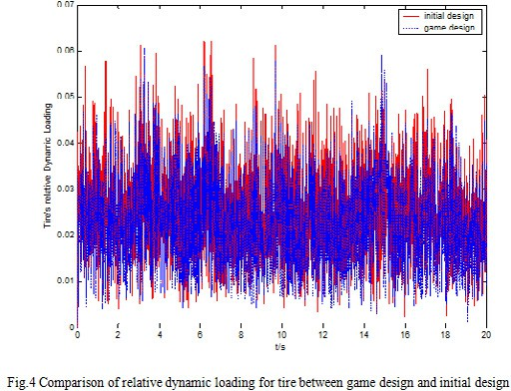

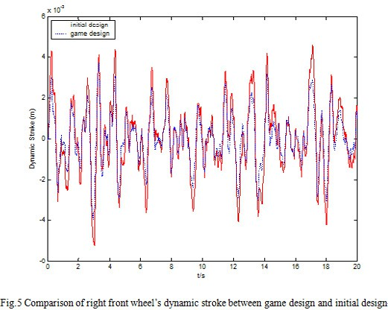 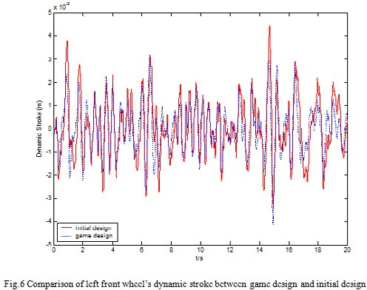

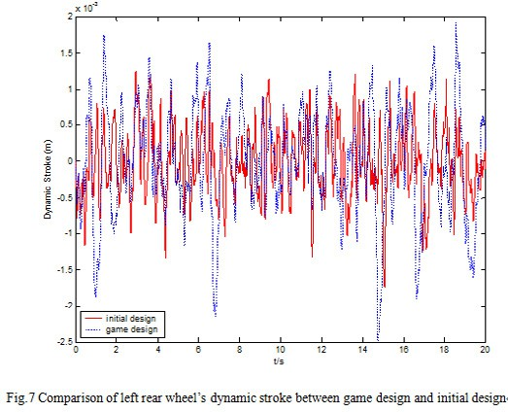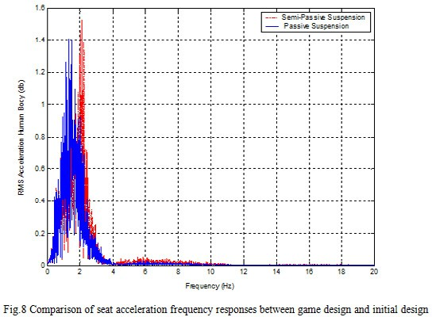

1. Conclusions

The paper adopts cooperative game. During the game, game partiers abide by some constraint protocol based on collective rationality; by negotiating, game partiers make some “concession” mutually, and reach trade-off equilibrium solution. Maybe the results is not the best optimal results to the game partiers, it is a relatively acceptable solution, which means the co-operative game result for multi-objective is a non-inferior solution.

Acknowledgements

Project supported by the National Natural Science Foundation of China (Grant No. 11072106 ), the National High Technology Research and Development Program of China (Grant No. 2008AA11A140).

References

1. Kaisa Miettinen. Nonlinear Multiobjective Optimization. Kluwer, Boston, (1999).
2. Hajela, P. and C. Lin . Genetic search strategies in multicriterion optimal design. Structural Optimization 1999(4), 99–107.
3. K.C. Tan, Y.H. Chew, L.H. Lee, A hybrid multi-objective evolutionary algorithm for solving truck and

trailer vehicle routing problems, European Journal of Operational Research 172 (2006) :855–885.

1. Song Chong Zhi,ZHAO Youqun. Multi-objective optimization design of vehicle suspension based on Stackelberg.2010 6th International Conference on Natural Computation, ICNC 2010: vol(6):2783- 2787.August,2010
2. Multi-objective optimization of eight-dof vehicle suspension based on game theory.Transactions of Nanjing University of Aeronautics and Astronautics.

June ,2010:138-147.